Table of Contents

ABSTRACT 2

CHAPTER 1 –INTRODUCTION 3

1.1 Objectives 14

1.2 System Specifications 15

CHAPTER 2 – LITERATURE REVIEW 16

CHAPTER 3 OVERALL DESCRIPTION OF THE PROPOSED SYSTEM 24

3.1 Module Description 24

CHAPTER 4 – DESIGN 27

4.1UML Diagrams: 27

**4.1.1Usecase Diagrams**: 28

**4.1.2 Sequence Diagram:** 30

**4.1.3 Collaboration Diagram:** 32

**4.1.3 DFD:** 33

**4.1.4 Work Flow Diagram:** 34

**4.1.5 Table Design:** 34

**4.1.6 ER Design:** 36

**4.1.7 Class Design:** 37

**4.1.8 Activity Design:** 37

CHAPTER 5 - OUTPUT SCREENSHOTS 39

CHAPTER 6 – IMPLEMENTATION DETAILS 41

6.1 Introduction to Html Framework 41

6.2 Cascading Style Sheets (CSS) 41

6.3 MYSQL Server 43

6.4PHP 44

6.5 ANGULAR JAVA SCRIPT 44

CHAPTER 7- SYSTEM STUDY 46

CHAPTER 8-TECHNICAL FEASIBILITY 47

CHAPTER 9-SYSTEM TESTING 50

CHAPTER 10– CONCLUSIONS 55

CHAPTER 11- REFERENCES 56

# ABSTRACT

Medical study has revealed that people set a bigger possibility of countering free radicals and warding off illness by consumption of healthy foods and by increasing their resistant system. Due to the poor eating habits people suffer from many diseases. In the current scenario fast food become important food in daily routine because it is effortlessly available but taking fast food in routine may cause for disease like heart attack, diabetics etc. Healthier diets help us to maintain our health and keep us away from many diseases. For better recovery from diseases or surgery etc individual have special needs according to their medical profile, cultural backgrounds and nutrient requirements. Design and implementation of healthy diet recommendation system is based on search which is the application of search technique help us to determine pattern .

# CHAPTER 1 –INTRODUCTION

Functions e.g. Create account, Filtration type (Gender wise, Specialty wise), Diet Expert Profile Reviews, Request for appointment, Patient received notification, Receive conformation notification before 2 hour. Diet Expert checks Patient history.

Benefits of Health Diet System

* Easy access to Diet Expert’s data to generate varied records, including classification based on demographic, gender, age, and so on. It is especially beneficial at ambulatory (out-patient) point, hence enhancing continuity of care. As well as, Internet-based access improves the ability to remotely access such data.
* It helps as a decision support system for the hospital authorities for developing comprehensive health care policies.
* Efficient and accurate administration of finance, diet of patient, engineering, and distribution of medical aid. It helps to view a broad picture of hospital growth
* Improved monitoring of drug usage, and study of effectiveness. This leads to the reduction of adverse drug interactions while promoting more appropriate pharmaceutical utilization.
* Enhances information integrity, reduces transcription errors, and reduces duplication of information entries.
* Hospital software is easy to use and eliminates error caused by handwriting. New technology computer systems give perfect performance to pull up information from server or cloud servers.

 The Health Diet System is developed to decrease the work that is done manually at Hospital centers. Every single step is done with the help of system, services such as employee registration, editing of different types such as employees , students into database , inquiries as well as complaints of customers. This Health Diet System will help in reducing lots of paper work and file work in these hospitals which will make easy management of hospital. It will also provide all the latest information to the management and hospital administration wherever they ask. Health Diet System also include the pharmacist where anyone can inquire about the drugs availability and the stock to be ordered as well as about its expiry date.

 There are a lot of benefits to the Health center by placing the system at their registration and at drug store office. At the same time the patients are also benefited using this system. They can get the work done within no time.

Using the Health Diet System is as simple as using the personal computer. Since end user computing is developing in our country, It is beneficial to both Health center and the patients. Every step is clearly defined and help is provided through out the application to the user.

 The heath center can get much out of the system. The Health Diet System is used to enter the patient details and to enter the details about the health center and the details about the in-patient and out-patient in detail and about the reports of the patients. This system represents the patient by the OP number and this is main criteria how the patient is provided by the free services.

The Health Diet System project helps to control the room allocation, medicine, prescriptions, payments, etc. Also, the administrator can register new employees and give the required rights to them.

The Health Diet System software is user-friendly software. The main objectives of the system is which shows and helps you to collect most of the information about Hospitality and Medical Services The system is very simple in design and to implement. The system requires very low system resources and the system will work in almost all configurations.

Whilst the exact relationship remains undefined and causality cannot be inferred, there is some research to date which links poor nutrition with a decrease in mental health. Vitamins and minerals assist with optimal functioning of neurotransmitters in the brain and O’Sullivan and colleagues (2008) note that “neurotransmitters are directly responsible for aspects such as behaviour, mood and intellectual function” (p. 254). In relation to mental health and brain functioning Jacka and Berk (2007) note that at the neurochemical level oxidative stress can cause neuronal damage, however foods high in antioxidants (e.g., blueberries, grapes, and green tea) can reduce the occurrence of neuronal damage. The mechanism for this relationship is commented on by Jacka and colleagues which in relation to depression notes that it “is influenced by genetic, hormonal, immunological, biochemical, and neurodegenerative factors.

Diet modulates each of these factors and, as a results, has a plausible impact on the development and course of this illness” (Jacka et al. 2010, p. 5). Others, such as Smith (1991), have linked the immune system to depression, and the immune system is also thought to be influenced by dietary habits (Jacka & Berk 2007). For example, magnesium deficiency (e.g., low intake of leafy green vegetables, nuts, legumes and whole grains) is associated with C-reactive protein – a marker for low grade inflammation (Jacka & Berk 2007). Dietary habits are thus likely to be important factors in immune status, which these researchers suggest may influence depression over time (Jacka & Berk 2007). A number of Australian researchers have also recently begun conducting research on diet and its association with symptoms of mental illness. In a large-scale Western Australia study researchers examined 1,631 adolescents (14-year-olds) and found two main food patterns: a ‘Western’ dietary pattern, which consisted of high intakes of take-away foods, soft drinks, confectionary, refined grains and full fat dairy products; and a ‘healthy’ dietary pattern, which consisted of high intakes of whole grains, fruit, vegetables, legumes and fish (Ambrosini et al. 2009). A study by the same research group identifies that higher scores of psychological symptoms relating to internalising (e.g., withdrawal/depression) and externalising behaviour (e.g., delinquency/aggression) were associated with a ‘Western’ dietary pattern, whereas a ‘healthy’ dietary pattern was associated with a decrease in symptoms (Oddy et al. 2009). Another study also showed that a ‘Western’ diet was associated with a higher likelihood of depressive and anxiety disorders in women (Jacka et al. 2010).

Furthermore, it has been identified that a high-quality breakfast, consisting of 3 of more food groups, is associated with better mental health scores in adolescence (O'Sullivan et al. 2008). For example, the researchers report that milk, fortified breakfast cereals and bread are good sources of nutrients (including carbohydrates, calcium, B vitamins, iron and folate) that positively affect brain function (O'Sullivan et al. 2008). Gender differences As alluded to earlier, differences in life expectancy between men and women continue to be evident today: the average life expectancy for Australian women is 84 years, whilst for men it is 79 years (Department of Health and Ageing [DOHA] 2010c). Health-related beliefs and behaviour significantly moderate these differences particularly in preventable/chronic diseases. The U.S. Preventive Services Task Force (1996) reviewed a large number of studies and estimated that half of all deaths could be prevented by making changes in personal health behaviours, such as diet. Research confirms that Australian men consume less fruits and vegetables than women (Centre for Public Health 2003). Compared to other groups, men aged 18-44 years also eat a smaller variety of vegetables (Centre for Public Health 2003). Men consume less high fibre foods, less low fat foods and more soft-drinks than women (e.g., Wardle et al. 2004). In this regard, researchers have identified that men face specific barriers to eating foods like fruit and vegetables (Dumbrell & Mathai 2008). This includes cost, time, lack of cooking skills, inconsistent quality, low availability, perishability and a lack of understanding as to recommended serving size (Dumbrell & Mathai, 2008). Furthermore, Dumbrell and Mathai (2008) identified in a sample of men aged 18 - 40 years that fruit and vegetables ranked lowly in Australian men’s culture – this was particularly noticeable in younger men aged 18 – 25 years where they were unconcerned about the health risks of diets low in fruit and vegetables. The researchers (Dumbrell & Mathai 2008) comment that Australian food marketing messages often link masculinity with animal products “or with the ‘hunter’ rather than ‘gatherer’ food traditions” (p. 217), whereas nutrition and cooking are socially constructed as feminine (e.g., far more women than men are cooks and homemakers on television) (Courtenay 2000).

Gender differences in health beliefs and dieting status have been found to moderate food choices (Wardle et al. 2004). Wardle and colleagues (2004) conducted a large-scale study of 19,298 university students from 23 different countries and found that for men health is a less important motivational factor when making food choices, than for women. They comment that it was not that men were not interested in the nutritional and health benefits of food, but that this was a less important quality for men, than it was for women. However, the gender differences in this study were small. This could be explained by Wardle and colleagues’ (2004) sample of university students which were mainly well-educated and from higher socio-economic circumstances – factors which could be limiting the extent of gender differentiation in that sample. Other researchers comment on the socially prescribed male role, and that there are stereotypical or socially prescribed masculinities which influences men’s health beliefs and behaviours (e.g., Courtenay 2000). For example, Courtenay (2000) comments that: A man who enacts gender as socially prescribed would be relatively unconcerned about his health and wellbeing and would place little value on health knowledge. He would see himself 6 as stronger, both physically and emotionally, than most women. He would think of himself as independent, not needing to be nurtured by others….

He would not be interested in learning about health, nutrition, or cooking, and he would be unconcerned about his weight, diet, or hygiene (p. 11) Courtenay (2000) argues that rather than gender residing in the person, men and women actively participate to construct these socially-based gendered norms. In turn the health beliefs and behaviours that an individual exhibit could characterize and enact representations of themselves and their gender (Courtenay 2000). In his review of literature Courtenay note that “a growing body of research provides evidence that men who endorse dominant norms of masculinity adopt poorer health behaviours and have greater health risks than their peers who endorse less traditional norms” (p. 3). Thus, in contrast to Wardle and colleagues’ study of university students from high socio-economic backgrounds (2004), it is possible that men from lower socio-economic circumstances, such as blue-collar workers (e.g., construction workers in jobs that are considered “men’s work”, Courtenay 2000, p. 7), might adhere more to masculine stereotypes, which might in turn influence their dietary beliefs and choices. Although less is known about blue-collar workers’ food consumption, research does show that white-collar populations have more favorable food patterns (Engbers et al. 2006).

Whilst dominant stereotypes have a powerful effect, others argue that the perpetuation of singular dominant masculine stereotypes is unhelpful in health promotion settings. For example, Smith (2007) cautions that these days the “masculine transition into adulthood has become more complex and transitional statuses (leaving home, marriage and employment) have become weakened” (p.22). As such, Smith (2007) argues for a greater acceptance of multiple masculinities in different groups of men, in order to target health promotion activities to the most vulnerable and marginalised men in society.

One of the theoretical frameworks frequently mentioned in health literature which has relevance to the stages of change that people experience as they make behavioural changes (e.g., to their diet), is that of Prochaska and DiClimente’s (1986) transtheoretical model. According to this framework behavioural change happens when individuals are ready to change, and it occurs in a cyclical process which might involve progress and relapse. The stages distinguished in the model include precontemplation (where behaviour change is not yet considered), contemplation (thinking about change), preparation (planning to change), action (actively changing) and maintenance (sustaining change) (Prochaska & DiClemente 1986).

Gracey and colleagues note that nutrition intervention programs are more likely to be successful if it considers factors which influence food choice, as well as a theoretical framework which incorporates a focus on changes in health-related behaviours, for example Prochaska and DiClemente’s stages of change model (Gracey et al. 1996). More recently, Walsh and Nelson (2010) noted the importance of increasing young men’s competencies in relation to food, and called for educators to consider the variety of factors which influences how young men think about food and the role it plays in their lives. Other researchers have similarly called for ‘innovative approaches’, including the importance of using participant suggestions in developing nutrition programs and the use of internet-based nutritional information in informing young adults (Cousineau et al. 2004). Mass media campaigns focused on preventing weight gain have been successful both overseas and in Australia

. A 3-year mass media campaign (‘Maak je niet dik!’ literally translated as ‘Don’t get fat’) implemented in the Netherlands resulted in high campaign awareness, more positive attitudes, greater social support and positive intentions to prevent weight gain (Wammes, Oenema & Brug 2007). Similarly the 2009 Western Australian ‘Draw the Line’ campaign, which aimed at maintaining a healthy weight, was effective in achieving high campaign awareness, understanding of campaign messages, and confidence in the target group’s ability to implement and sustain weight-related behaviours (Ivery et al. 2010). Nutrition education programs are frequently combined with exercise interventions in community health promotion programs.

Targeting both physical activity and nutrition can offer a greater number of health promotion opportunities and maximise positive health outcomes for participants (Prochaska & Sallis 2004). Researchers note that exercise and dietary behaviour are influenced by conscious choices (for which increasing health knowledge is useful) and unconcsious processes or habits (for which changes in the physical environment is beneficial) (Engbers et al. 2005). Increasingly, multi-behaviour programs are taking a whole-of-community approach to target obesity (e.g., Victorian-based Health Promoting Communities: Being Active Eating Well initiative - De SilvaSanigorski et al. 2010). However, some researchers caution that multi-behaviour interventions are often costly to implement and need to be time-efficient to maximise its potential, without overloading participants (Prochaska & Sallis 2004). Settings approaches (e.g., schools/workplace) have been acknowledged as a targeted means to reach specific populations (Smith 2007). School-based interventions implemented as part of the curriculum have shown success in reducing obesity (particularly among girls), decreasing television viewing and increasing fruit and vegetable consumption (Gortmaker et al. 1999). However, another multi-behaviour intervention which focused on environmental changes as opposed to changes incorporated in the curriculum, have shown limited effectiveness (Sallis et al. 2003).

Specifically these environmental changes included increased physical activity in physical education classes, regulated provision of low-fat foods in cafeterias, and health policy interventions such as health promotion newsletters to parents (Sallis et al. 2003). This study (Sallis et al. 2003) showed that making environmental changes improved boys’ physical activity and BMI levels, but not dietary intake (and no changes were found to girls’ physical activity levels or dietary intake). In another study brief school-based interventions (30 minutes targeting physical activity and nutrition) have also shown limited efficacy at improving adolescent boys’ (M = 12 years) physical acitivity levels, however it had no effect on improving their fruit and vegetable intake (Prochaska & Sallis 2004).

Implementing health promotion changes through the workplace can contribute to healthier lifestyles, reduced absenteeism, and increased productivity (e.g., DOHA 2010b). A large portion of each day is often spent at work, as such it is a convenient site for intervention (i.e., the workers are already there), often there is collegial support (or an opportunity to increase support) and, with the support of employers, space and time to implement health-related messages and make environmental changes. A review of workplace interventions show that they are successful in addressing dietary behaviours (Steyn et al. 2009). Some workplace interventions show changes in the psychosocial determinants of dietary behaviour (e.g., more collegial support to eat healthy in the workplace) (Engbers 2006). However, others show tangible results.

For example, a study of New Zealand blue-collar men in a manufacturing workplace compared an intervention group (nutrition displays in cafeteria and 30-minute monthly workshops) with a control group, and after 6 months demonstrated not only high retention in the workplace program, but also signficant changes in fat intake, fruit and vegetable intake and nutritional knowledge (Cook et al. 2001). Engbers and colleagues (2005) conducted a systematic review of 13 randomised control trials which implemented workplace health promotion programs. Their review found strong evidence that workplace health promotion programs can successfully influence dietary intake. Modifying the environment, including food labelling, displaying promotional posters and brochures, expanding the available healthful food choices, and product placement, all contributed to successful dietary changes (including increased fruit and vegetable intake and reduced fat intake) (Engbers et al. 2005). However, there was inconclusive evidence that environmental changes affected anything but dieatary intake (e.g., physical activity levels or health risk indicators) (Engbers et al. 2005).

Amongst its initiatives, the National Partnership Agreement wants to support healthy living programs in workplaces in States and Territories, which would include focusing on topics such as physical activity and healthy eating (COAG 2008). More recently, the first National Male Health Policy, also encouraged the workplace as a setting for targeted health promotion interventions, awareness raising and health checks (DOHA 2010c). An example of how these programs are implemented is the Victorian Government’s WorkHealth checks across Victorian workplaces, including the construction industry (www.workhealth.vic.gov.au). These 15-minute health checks delivered by endorsed clinical practitioners in the workplace tests key risk factors (e.g., cholesterol, blood pressure, blood sugar) and includes the provision of targeted educational materials to encourage preventative action in specific areas (e.g., increasing fruit and vegetable intake). As part of their initiatives WorkSafe also implement targeted and tailored workplace programs in conjunction with employers.

For example, this might target increasing physical activities (e.g., lunchtime walking groups) or dietary changes (e.g., provision of fresh fruit and vegetables by employers). More recently, the Australian Government announced its Food and Health Dialogue, which together with industry and public health groups aims to address poor diet and promote healthy food choices (DOHA 2010a). A Reformulation Working Group has been established under this initiative to investigate a number of food categories, including bread and breakfast cereals, savoury pies, and 10 sweet biscuits. To date the Working Group has secured an agreement with industry to reduce salt in bread and breakfast cereals (DOHA 2010a).

## Objectives

This system enables user friendly for Diet Expert-Patients relationship. Diet Expert can easily diagnosis patient’s problem and find out the solution and they provide update details about patient’s problems.

## System Specifications

**Software Requirements: -**

Front End: HTML5, CSS3, Bootstrap

Back End: PHP 7.4, MYSQL

Control End: Angular Java Script

**Android Tools:**

IDE: Android Studio

Android Emulator

xampp-win64-7.4

**Hardware Requirements:**

Processor : Intel 3

Installed memory (RAM) : 4 GB

Hard Disk : 500 GB

Operating System : Windows 7,8,10 - 64 bit

# CHAPTER 2 – LITERATURE REVIEW

Collen (1986) described the development of approaches in the 1970s that sought to approximate the habitual processes of decision-making with the use of artificial intelligence in differential diagnoses. In the same decade, studies were undertaken in search of a better organization of the healthcare system (Kaihara, 1978). With the help of computer-processed simulations, the author established an ideal relationship between medical centers and population demands.

The distributed processing was expanded during the 1980s with the development and greater availability of microcomputers, and the possibility of network communication of such equipment increased in the 1990s (Stumpf and Freitas, 1997). This allowed for the emergence of hospital information systems (HIS), covering medical, administrative, and hospitality areas, although hospitality may be considered as integrated into the administrative area (Cortes, 2008). These three areas are interlinked by horizontal data and information flows, providing support to the developed activities. [Figure 1](http://www.scielo.br/scielo.php?script=sci_arttext&pid=S1807-17752011000100008#fig01) shows a sample record for use in the medical, administrative, and hospitality areas, generating inter-related demands and actions. In the proposed scheme, the information on the electronic records, which contain the procedures, prescriptions, laboratory examinations, professionals involved, and hospitalizations (when applicable), is fundamental for an HIS (Wakamiya and Yamauchib, 2009; Pinochet and Albertin, 2008).

eHospital Systems is a hospital management system software designed to manage all aspects of a hospital operation. This customizable hospital information system is an integrated healthcare solution which includes OPD and IPD Management, Pharmacy, Laboratory, Radiology, Ward Management, Mobile Application, Online Appointments Scheduling, Secured Messaging, Diet Expert Portal, Patient and Family Portals, Medical Electronic Billing, Accounting System

The use of computers in medicine dates back to the 1950s with studies that attempted to expand the mental capacity of physicians (Stumpf and Freitas, 1997) or dealt with research on electrophysiology (Collen, 1986). With the evolution of this equipment, especially with the capacity to simultaneously execute various tasks beginning in the 1960s, computers began to be used in the processing of information in large hospitals, in both administrative and financial functions for the collection of statistics and the development of research projects (Stead, 2007; Stumpf and Freitas, 1997). The use of microcomputers, beginning in the 1970s, introduced the concept of distributed processing, increasing the number of systems in use in large hospitals (Stumpf and Freitas, 1997).

Because this diffusion did not always occur in an organized or homogeneous manner, the initial diffusion of computers in hospitals led to the emergence of islands of computerization, with isolated systems that lacked any form of interconnection and were developed by different teams. The redundancy and the lack of data integrity deterred health professionals, who saw these systems as developed by systems professionals for systems professionals (Stumpf and Freitas, 1997). This situation was also investigated by McDonald (1997), who analyzed the lack of interconnection of the different systems used by the hospitals, laboratories, and service providers in the healthcare field.

Nutrients are consumed through the food that we eat, and through metabolic processes in the digestive system these nutrients are absorbed at a cellular level in the body (Gibney et al. 2009). Optimum nutrition contributes to health, wellbeing, normal development, and high quality of life (Gibney et al. 2009). However, undernutrition, overnutrition, and malnutrition are linked to suboptimal health outcomes (Gibney et al. 2009). Such poor diets have been linked to the occurrence of chronic diseases, including cardiovascular disease, Type-2 diabetes, cancer, osteoporosis and anaemia (Lytle et al. 2002). For example, research reports that low intake of fruit and vegetables increases the risk for developing cancer (Steinmetz & Potter 1996), as well as cardiovascular disease (Hung et al. 2004), whereas low intake of dietary fibre has been linked to being overweight (Patrick et al. 2004). Obesity is often a consequence of overnutrition, and it is an ever-increasing problem in both developing and food-secure countries, such as Australia (Gibney et al. 2009). A recent longitudinal study conducted in Victoria report on the significant increase of obesity from adolescence to adulthood (Patton et al. 2010). This study of 1520 adolescents tracked over a period of 10 years also highlights the decreased likelihood of overweight adolescents achieving a normal weight in adulthood (Patton et al. 2010). Frequently linked with a greater proneness to Type-2 diabetes (e.g., Wang, Hoy & Si 2010), obesity severely affects health-related quality of life in a range of domains, including, physical, social and psychological (Mannucci et al. 2010). However, factors influencing

obesity and chronic diseases are more complex than diet alone. For example, together with increased sedentary behaviour, decreased physical activity has been shown to play a crucial role in becoming overweight and obese (Patrick et al. 2004). For the purposes of this project, and literature review, the focus will be on the diet and nutrition of apprentices, although the influence of other factors (e.g., lifestyle and environmental factors) is acknowledged, but noted as outside the scope of this project.

Individuals’ reasons for buying and eating particular foods have been described as a “complex biopsychosocial process that is relative to person, place and time” (Walsh & Nelson 2010, p. 194). Most researchers believe that dietary habits and food preferences develop in childhood, are established by age 15, and become habitual in due course (Birch 1999; Sweeting & Anderson 1994). Adolescence is thus still a key formative period in the development of eating habits (Walsh & Nelson 2010). Of interest is that some studies have identified a negative shift in the recommended nutrient consumption during adolescence, with reports that few adolescents are meeting recommend dietary guidelines (Patrick et al. 2004). For example, Lytle and colleagues (2002) conducted a large-scale longitudinal study of youth between the ages of 8 and 14, and found that their diets became less nutrient-dense over time. In particular, this study found that during adolescence young people’s diets showed an increase in fat, saturated fat and sodium, and a decrease in vitamins, minerals and fibre – these nutrients are all those implicated in chronic disease (Lytle et al. 2002). Adolescents have also been found to consume less than adequate amounts of fruits and vegetables. A large-scale study of 16,262 U.S. youth (with a mean age of 16 years) identified that only 22% of young women and 29% of young men consumed the recommended daily fruit and vegetable serves (Pesa & Turner 2001). Construction industry apprentices (most often young men aged 16-24 years) could be considered ‘vulnerable’ due to the number of transitional issues and changes they face as they move from school to work. These changes include: Changes to their physical environment (e.g., moving out of the parental home; cohabiting with friends or a romantic partner), changes to their peer group (as new employees on a worksite, fellow-apprentices, new friends), changes in financial responsibilities (e.g., paying rent, purchasing a vehicle, purchasing food, paying bills), and educational/work responsibilities (e.g., successfully completing apprenticeship, performing successfully at work).

Lytle and colleagues (2002) argue that the transition to adolescence, where young people experience an increased need for autonomy and a desire to express themselves, influences young people’s food choices. Furthermore, youth experience peer pressure which significantly influences their food choices (Lytle et al. 2002). In comparison to younger children, teens might also be exposed to more unhealthy food choices in their environment (Lytle et al. 2002). Apart from transitional issues there are also a number of collective factors which influences the decisions individuals make about food, which includes familial factors, food supply, and food acquisition (e.g., at home, work, markets, and through fast-food outlets) (Taylor, Evers & McKenna 2005). Recent research conducted with Irish adolescents (Walsh & Nelson 2010) indicates that parents are the biggest influencers in their children’s diets. In particular the frequency of shared dinners had a positive effect on adolescents’ food knowledge (Walsh & Nelson 2010). Other factors influencing

adolescents’ diets included their nutritional knowledge, friends (with whom high-fat fast foods were often consumed), government health campaigns and cooking programs on television (Walsh & Nelson 2010). However, this study found that celebrity endorsements of food products had the least influence on adolescents’ diets (Walsh & Nelson 2010). Other researchers note that the media, in particular television, promotes differential food marketing to youth (Lytle et al. 2002). A study by Wiecha and colleagues highlights the important role of television in shaping young people’s intake of increased calorie-rich, low-nutrient food often advertised on television, and also explicitly links increased television viewing with increased calorie intake (Wiecha et al. 2006). Food labelling and marketing of products also influence the choices that individuals make around food. For example, Jalleh and Donovan (2001) demonstrated that even though two products were identical, the positive framing of product attributes (e.g., 75% fat free) as opposed to negative framing (e.g., 25% fat content) influenced consumers’ choice of purchasing the positively-framed product, as well as their positive perceptions of the product’s taste and quality. Demographic factors, socio-economic status, as well as ethnicity, social, and cultural variables also influence food choices (Tepper, Choi & Nayga 1997). At the individual level numerous aspects such as hunger and satiety, food preferences, and attitudes and beliefs about food influence decisions around food (Tepper et al. 1997). Gracey and colleagues (1996) identified that 15-year old adolescent boys report the effects of a healthy diet to be ‘an improvement in health’, ‘feeling energetic’, ‘feeling good about myself’, ‘lowering cholesterol’ and ‘improving appearance’. These adolescent boys also identified some barriers to healthy eating, including healthy food not being available at home or in the school canteen, a lack of control over foods available at home, and a lack of nutritional knowledge (e.g., calorie content, sugar/fat content, fibre content) (Gracey et al. 1996). Nutritional knowledge has been indicated as a factor which influences food choice. However, some researchers question whether an increase in nutritional knowledge necessarily eventuates in improved food choices (Tepper et al. 1997), whilst other researchers have found that nutritional knowledge alone is insufficient to motivate healthy eating (Gracey et al. 1996).

Although fewer men than women report that they have ‘dieted’ (Liebman et al. 2001), men’s food choices have been found to be moderated by dietary restraint (defined as “the conscious attempt by an individual to regulate body weight”, Tepper et al. 1997, p.308). In their study of 137 males in a U.S. community sample, Tepper and colleagues (1997) found that dietary restraint was a definite factor influencing food choices, with men high in restraint more likely to consume healthy foods and less likely to consume fast foods, fats and oils, and soft drinks. Others report that men, in general, give preference to taste and convenience, over healthful food choices (Wardle et al. 2004). While unhealthy eating practices established during childhood and adolescence might interfere with optimal growth and development (Taylor, Evers & McKenna 2005), it is of greater concern that these food practices tend to endure into adulthood (Ambrosini et al. 2009). Some researchers believe that this is a contributing factor to the eventual differences in life-expectancy between men and women (Wardle et al. 2004).

Australian research indicates that between 1985 and 1995 there was an increase in total energy consumption (e.g., carbohydrates, sugars, soft drinks, and confectionary) in children and adolescents 4 (Cook, Rutishauser & Seelig 2001). Approximately a quarter of Australian adolescents are overweight or obese, and the last 20 years saw an increase in children and adolescents who have become overweight (which has doubled) or obese (which has tripled) (Booth et al. 2006). During this same period physical exercise has decreased and there has been a marked increase in time spent on sedentary behaviours (e.g., watching TV and using computers) (Booth et al. 2006). Research has found that mental disorders now account for 49% of the ‘burden of disease’ amongst Australians aged 15 - 24 years (AIHW 2007), and it has risen 5 to 8-fold among youth of developing nations in recent decades (Eckersley 2008). A recent large-scale Australian study of more than 10,000 students found that students’ wellbeing particularly decreased during high school (Bernard, Stephanou & Urbach 2007). Eckersley (2008) comments that youth “appear to be suffering mental health problems at an earlier age than before, experiencing them at higher rates than older age groups, and retaining their increased risk beyond youth into older age” (p.10). A quarter of 16-24 year olds report experiencing a mental disorder (e.g., depression, anxiety, substance use disorders etc.) (ABS 2008). Young men, in particular, are at risk of suicide with 24% of deaths in young Australian men aged 15 -24 years accounted for by suicide (ABS 2010).

**Existing Solution:**

* The work is done manually.
* Those who are interested in maintain health they have walk to the dietitian clinic.
* This creates a huge Relief for the user of the Office on weekends to save their time.
* Some of the website are available but there is only static designed. But this project enhanced dynamic system.

**Proposed Solution:**

* A new system is helpful to user as well as the dietitian.
* New system provides help to the user as they can know about the food habit, exercises, wakeup details and etc. and they don’t need to walk to the office.
* This project is over come to existing system are reduce time consuming and money saving also.
* They can post feedback by user and view the diet expert.

# CHAPTER 3 OVERALL DESCRIPTION OF THE PROPOSED SYSTEM

## 3.1 Module Description

This system enables user friendly for Diet Expert-Patients relationship. Diet Expert can easily diagnosis patient’s problem and find out the solution. Diet Expert provide update details about patient’s problems.

**3.2 System Features**

In the life of the software development, problem analysis provides a base for design and development phase. The problem is analyzed so that sufficient matter is provided to design a new system. Large problems are sub-divided into smaller once to make them understandable and easy for finding solutions. Same in this project all the task are sub-divided and categorized.

**System Modules:**

* **USER**
* Register
* Login
* My Profile
* Post Query
* View Solution
* Post Feedback
* **Diet Expert**
* Register
* Login
* View Query
* Post Solution
* View Feedback
* Publish Common Details

**3.3 MODULES:**

* **USER:**
* **Register and Login:**

User enters this system after they can register and login .

* **Post Query:**

User can login this system after they can post their own queries about their diet maintain.

* **View solution:**

User can login this system after they can view solution.

* **Post feedback:**

User can post feedback about their solution or response.

* **DIET EXPERT:**
* **Register and Login:**

Diet Expert can register and login this system after they can view home page.

* **View Query:**

Diet Expert enters this system and view user and public post their query details

* **Post solution:**

Diet Expert can only post solution for public and user queries.

* **View feedback:**

Diet Expert can view the feedback about their solution.

* **Publish Common Details:**

Diet Expert can publish common details about any new information to their own website.

# CHAPTER 4 – DESIGN

Design is the first step in the development phase for any techniques and principles for the purpose of defining a device, a process or system in sufficient detail to permit its physical realization.

Once the software requirements have been analyzed and specified the software design involves three technical activities - design, coding, implementation and testing that are required to build and verify the software.

The design activities are of main importance in this phase, because in this activity, decisions ultimately affecting the success of the software implementation and its ease of maintenance are made. These decisions have the final bearing upon reliability and maintainability of the system. Design is the only way to accurately translate the customer’s requirements into finished software or a system.

Design is the place where quality is fostered in development. Software design is a process through which requirements are translated into a representation of software. Software design is conducted in two steps. Preliminary design is concerned with the transformation of requirements into data.

## 

## 4.1UML Diagrams:

UML stands for Unified Modeling Language. UML is a language for specifying, visualizing and documenting the system. This is the step while developing any product after analysis. The goal from this is to produce a model of the entities involved in the project which later need to be built. The representation of the entities that are to be used in the product being developed need to be designed.

There are various kinds of methods in software design:

* Use case Diagram
* Sequence Diagram
* Collaboration Diagram

**4.1.1Usecase Diagrams**:

Use case diagrams model behavior within a system and helps the developers understand of what the user require. The stick man represents what’s called an actor.Use case diagram can be useful for getting an overall view of the system and clarifying who can do and more importantly what they can’t do.





Use case diagram consists of use cases and actors and shows the interaction between the use case and actors.

* The purpose is to show the interactions between the use case and actor.
* To represent the system requirements from user’s perspective.
* An actor could be the end-user of the system or an external system.

**4.1.2 Sequence Diagram:**

Sequence diagram and collaboration diagram are called INTERACTION DIAGRAMS. An interaction diagram shows an interaction, consisting of set of objects and their relationship including the messages that may be dispatched among them.

A sequence diagram is an introduction that empathizes the time ordering of messages. Graphically a sequence diagram is a table that shows objects arranged along the X-axis and messages ordered in increasing time along the Y-axis.



**4.1.3 Collaboration Diagram:**

A **collaboration diagram** is a type of visual presentation that shows how various software objects interact with each other within an overall IT architecture and how users can benefit from this **collaboration**. A **collaboration diagram** often comes in the form of a visual chart that resembles a flow chart.

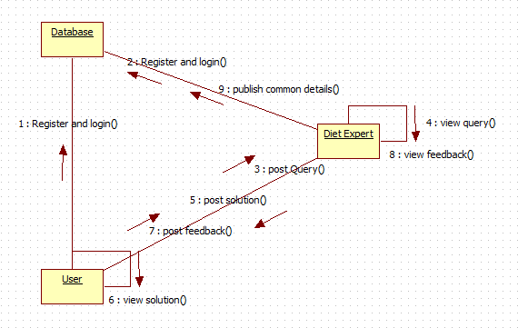

**4.1.3 DFD:**

**USER**

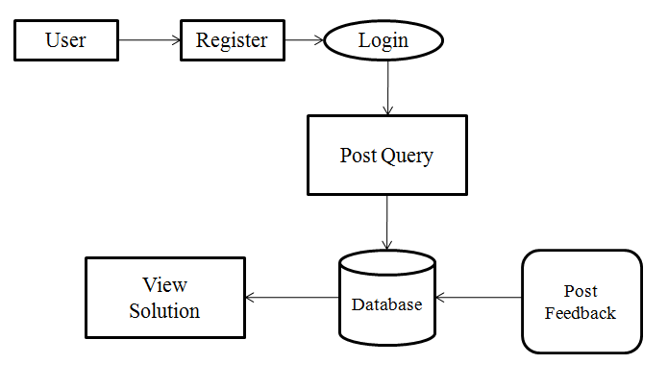

**DIET EXPERT**

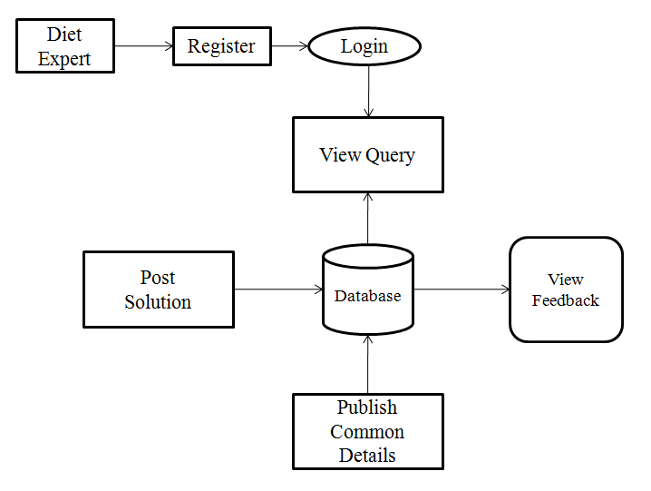

**4.1.4 Work Flow Diagram:**

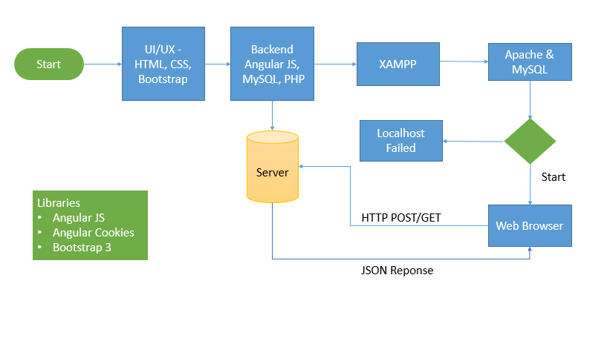

**4.1.5 Table Design:**

**Admin Login**

|  |  |  |  |  |
| --- | --- | --- | --- | --- |
| User ID | Name | Email Id | Password | Mobile |
| Int | Varchar | Varchar | Varchar | Varchar |
| 100 | 100 | 100 | 100 | 100 |
| Primary key |  |  |  |  |

**User Register & Login**

|  |  |  |  |  |  |  |  |
| --- | --- | --- | --- | --- | --- | --- | --- |
| ID | Name | Email | Password | Mobile | Address | Secuirty Question 1 | Secuirty Question 2 |
| Int | Varchar | Varchar | Varchar | Varchar | Varchar | Varchar | Varchar |
| 100 | 100 | 100 | 100 | 100 | 100 | 100 | 100 |
| Primary key |  |  |  |  |  |  |  |

**Diet Profile Details**

|  |  |  |  |  |  |  |  |
| --- | --- | --- | --- | --- | --- | --- | --- |
| User ID | Name | Age | Height – Weight | Current Food Habit | Diet For | Dieases | Gender |
| Int | Varchar | Varchar | Varchar | Varchar | Varchar | Varchar | Varchar |
| 100 | 100 | 100 | 100 | 100 | 100 | 100 | 100 |
| Primary key |  |  |  |  |  |  |  |

**BMI Level**

|  |  |  |  |  |
| --- | --- | --- | --- | --- |
| User ID | Email | BMI | Height | Weight |
| Int | Varchar | Varchar | Varchar | Varchar |
| 100 | 100 | 100 | 100 | 100 |
| Primary key |  |  |  |  |

**BMI History**

|  |  |  |  |  |
| --- | --- | --- | --- | --- |
| User ID | Email | Time | Diet | Status |
| Int | Varchar | Varchar | Varchar | Varchar |
| 100 | 100 | 100 | 100 | 100 |
| Primary key |  |  |  |  |

**Health Profile Details**

|  |  |  |  |  |  |  |  |
| --- | --- | --- | --- | --- | --- | --- | --- |
| User ID | Diet | Description | Age | Cure | Food Habits | Diet Taken | Process |
| Int | Varchar | Varchar | Varchar | Varchar | Varchar | Varchar | Varchar |
| 100 | 100 | 100 | 100 | 100 | 100 | 100 | 100 |
| Primary key |  |  |  |  |  |  |  |

**4.1.6 ER Design:**

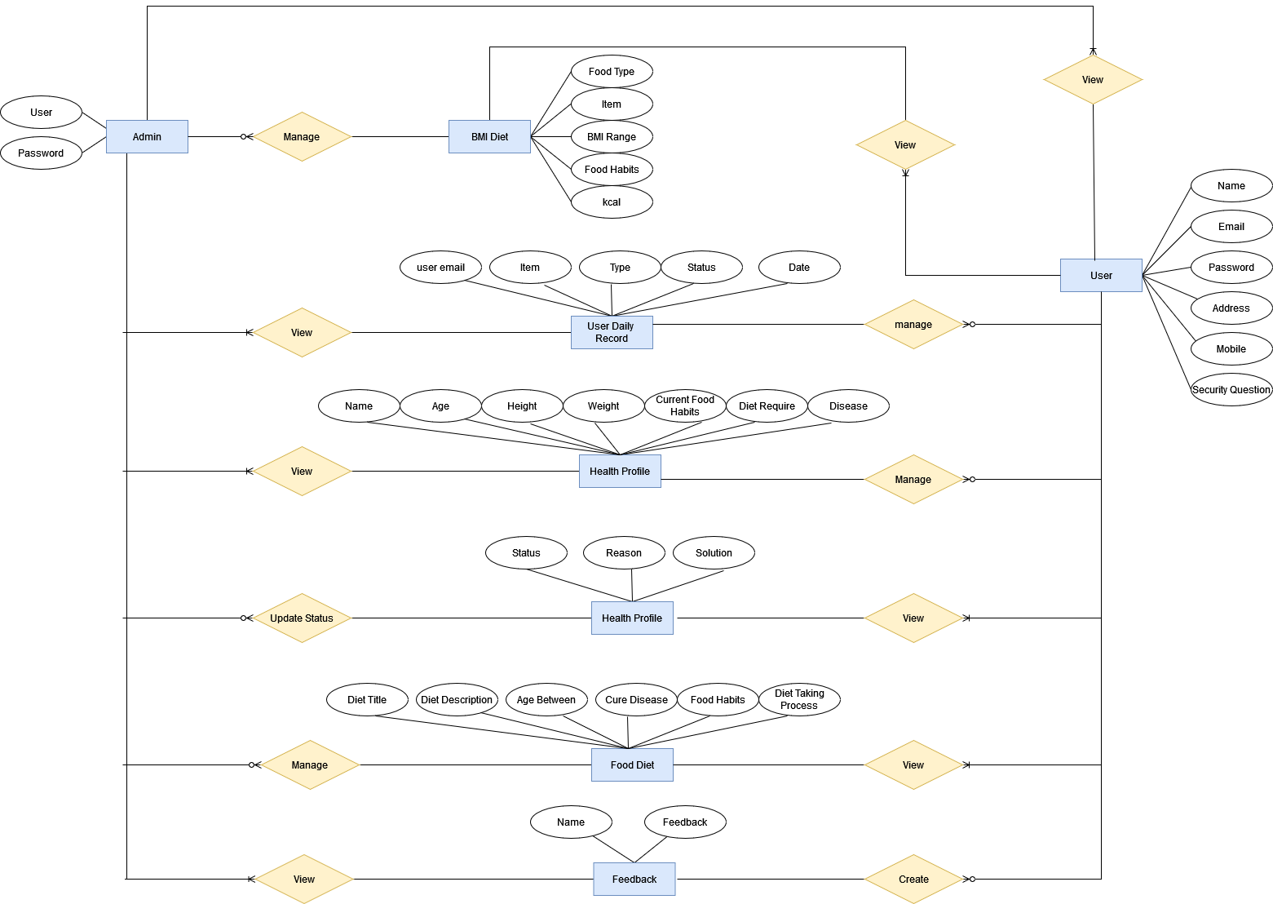

**4.1.7 Class Design:**



**4.1.8 Activity Design:**



# CHAPTER 5 - OUTPUT SCREENSHOTS

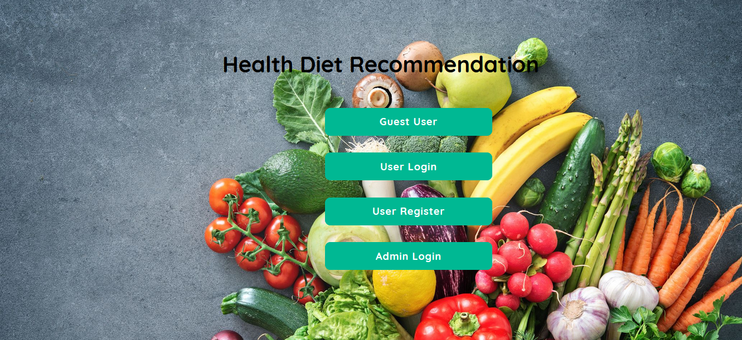

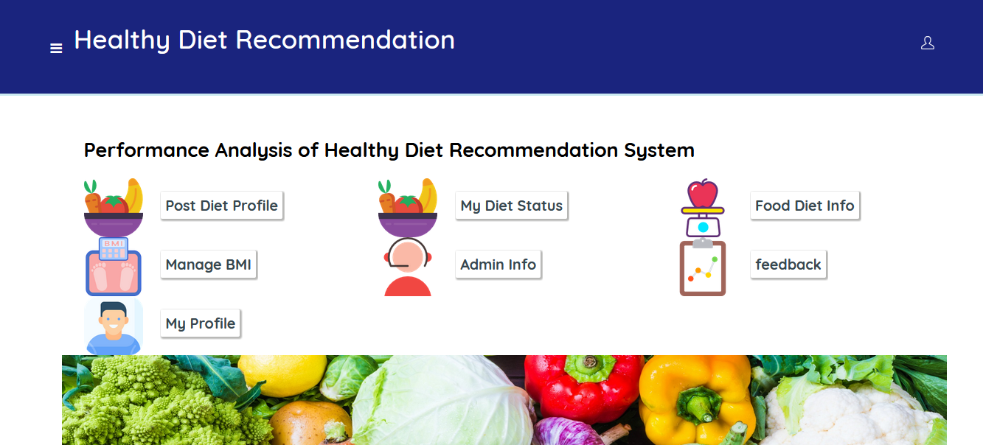

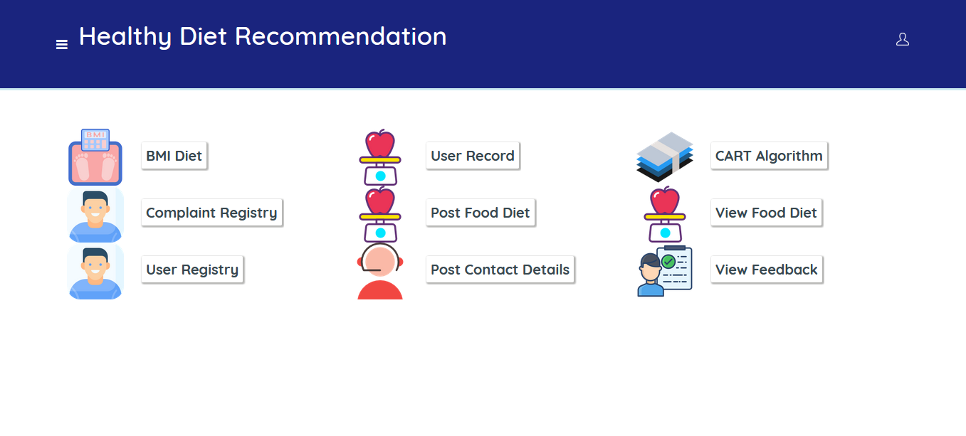

# CHAPTER 6 – IMPLEMENTATION DETAILS

## 6.1 Introduction to Html Framework

HyperText Markup Language, commonly referred to as HTML, is the standard [markup language](https://en.wikipedia.org/wiki/Markup_language) used to create [web pages](https://en.wikipedia.org/wiki/Web_page). Along with [CSS](https://en.wikipedia.org/wiki/Cascading_Style_Sheets), and [JavaScript](https://en.wikipedia.org/wiki/JavaScript), HTML is a cornerstone technology used to create web pages, as well as to create user interfaces for mobile and [web applications](https://en.wikipedia.org/wiki/Web_applications). [Web browsers](https://en.wikipedia.org/wiki/Web_browser) can read HTML files and render them into visible or audible web pages. HTML describes the structure of a [website](https://en.wikipedia.org/wiki/Website) [semantically](https://en.wikipedia.org/wiki/Semantic) along with cues for presentation, making it a markup language, rather than a [programming language](https://en.wikipedia.org/wiki/Programming_language).

[HTML elements](https://en.wikipedia.org/wiki/HTML_element) form the building blocks of HTML pages. HTML allows [images](https://en.wikipedia.org/wiki/Img_(HTML_element)) and other objects to be embedded and it can be used to create [interactive forms](https://en.wikipedia.org/wiki/Fieldset). It provides a means to create [structured documents](https://en.wikipedia.org/wiki/Structured_document) by denoting structural[semantics](https://en.wikipedia.org/wiki/Semantics) for text such as headings, paragraphs, lists, [links](https://en.wikipedia.org/wiki/Hyperlink), quotes and other items. HTML elements are delineated bytags, written using [angle brackets](https://en.wikipedia.org/wiki/Bracket#Angle_brackets). Tags such as <img /> and <input /> introduce content into the page directly. Others such as <p>...</p> surround and provide information about document text and may include other tags as sub-elements. Browsers do not display the HTML tags, but use them to interpret the content of the page.

HTML can embed [scripts](https://en.wikipedia.org/wiki/Scripting_language) written in languages such as [JavaScript](https://en.wikipedia.org/wiki/JavaScript) which affect the behavior of HTML web pages. HTML markup can also refer the browser to [Cascading Style Sheets](https://en.wikipedia.org/wiki/Cascading_Style_Sheets) (CSS) to define the look and layout of text and other material

## 6.2 Cascading Style Sheets (CSS)

CSS is a [style sheet language](https://en.wikipedia.org/wiki/Style_sheet_language) used for describing the [presentation](https://en.wikipedia.org/wiki/Presentation_semantics) of a document written in a [markup language](https://en.wikipedia.org/wiki/Markup_language). Although most often used to set the visual style of [web pages](https://en.wikipedia.org/wiki/Web_page) and user interfaces written in [HTML](https://en.wikipedia.org/wiki/HTML) and [XHTML](https://en.wikipedia.org/wiki/XHTML), the language can be applied to any [XML](https://en.wikipedia.org/wiki/XML) document, including [plain XML](https://en.wikipedia.org/wiki/Plain_Old_XML), [SVG](https://en.wikipedia.org/wiki/Scalable_Vector_Graphics) and[XUL](https://en.wikipedia.org/wiki/XUL), and is applicable to rendering in [speech](https://en.wikipedia.org/wiki/Speech_synthesis), or on other media. Along with HTML and [JavaScript](https://en.wikipedia.org/wiki/JavaScript), CSS is a cornerstone technology used by most websites to create visually engaging webpages, user interfaces for [web applications](https://en.wikipedia.org/wiki/Web_applications), and user interfaces for many mobile applications.

CSS is designed primarily to enable [the separation of document content from document presentation](https://en.wikipedia.org/wiki/Separation_of_presentation_and_content), including aspects such as the [layout](https://en.wikipedia.org/wiki/Page_layout), [colors](https://en.wikipedia.org/wiki/Color), and [fonts](https://en.wikipedia.org/wiki/Typeface). This separation can improve content [accessibility](https://en.wikipedia.org/wiki/Accessibility), provide more flexibility and control in the specification of presentation characteristics, enable multiple HTML pages to share formatting by specifying the relevant CSS in a separate .css file, and reduce complexity and repetition in the structural content, such as [semantically insignificant tables](https://en.wikipedia.org/wiki/Tableless_web_design) that were widely used to format pages before consistent CSS rendering was available in all major browsers. CSS makes it possible to separate presentation instructions from the HTML content in a separate file or style section of the HTML file. For each matching [HTML element](https://en.wikipedia.org/wiki/HTML_element), it provides a list of formatting instructions. For example, a CSS rule might specify that "all heading 1 elements should be [bold](https://en.wikipedia.org/wiki/Bold)", leaving pure semantic HTML markup that asserts "this text is a level 1 heading" without formatting code such as a<bold> tag indicating how such text should be displayed.

This separation of formatting and content makes it possible to present the same markup page in different styles for different rendering methods, such as on-screen, in print, by voice (when read out by a speech-based browser or[screen reader](https://en.wikipedia.org/wiki/Screen_reader)) and on [Braille-based](https://en.wikipedia.org/wiki/Braille_display), tactile devices. It can also be used to display the web page differently depending on the screen size or device on which it is being viewed. Although the author of a web page typically links to a CSS file within the markup file, readers can specify a different style sheet, such as a CSS file stored on their own computer, to override the one the author has specified. If the author or the reader did not link the document to a style sheet, the default style of the browser will be applied. Another advantage of CSS is that aesthetic changes to the [graphic design](https://en.wikipedia.org/wiki/Graphic_design) of a document (or hundreds of documents) can be applied quickly and easily, by editing a few lines in one file, rather than by a laborious (and thus expensive) process of crawling over every document line by line, changing markup.

The CSS specification describes a priority scheme to determine which style rules apply if more than one rule matches against a particular element. In this so-called cascade, priorities (or weights) are calculated and assigned to rules, so that the results are predictable.

## 6.3 MYSQL Server

MySQL  is an [open-source](https://en.wikipedia.org/wiki/Open-source) [relational database management system](https://en.wikipedia.org/wiki/Relational_database_management_system) (RDBMS);[[6]](https://en.wikipedia.org/wiki/MySQL#cite_note-6) in July 2013, it was the world's second most widely used RDBMS, and the most widely used open-source [client–server model](https://en.wikipedia.org/wiki/Client%E2%80%93server_model) RDBMS. It is named after co-founder [Michael Widenius](https://en.wikipedia.org/wiki/Michael_Widenius)'s daughter, My. The [SQL](https://en.wikipedia.org/wiki/SQL) acronym stands for [Structured Query Language](https://en.wikipedia.org/wiki/Structured_Query_Language). The MySQL development project has made its [source code](https://en.wikipedia.org/wiki/Source_code) available under the terms of the [GNU General Public License](https://en.wikipedia.org/wiki/GNU_General_Public_License), as well as under a variety of [proprietary](https://en.wikipedia.org/wiki/Proprietary_software) agreements. MySQL was owned and sponsored by a single [for-profit](https://en.wikipedia.org/wiki/Business) firm, the [Swedish](https://en.wikipedia.org/wiki/Sweden)company [MySQL AB](https://en.wikipedia.org/wiki/MySQL_AB), now owned by [Oracle Corporation](https://en.wikipedia.org/wiki/Oracle_Corporation). For proprietary use, several paid editions are available, and offer additional functionality.

## 6.4PHP

PHP is a [server-side scripting](https://en.wikipedia.org/wiki/Server-side_scripting) language designed for [web development](https://en.wikipedia.org/wiki/Web_development) but also used as a [general-purpose programming language](https://en.wikipedia.org/wiki/General-purpose_programming_language). Originally created by [RasmusLerdorf](https://en.wikipedia.org/wiki/Rasmus_Lerdorf) in 1994, the PHP [reference implementation](https://en.wikipedia.org/wiki/Reference_implementation) is now produced by The PHP Group. PHP originally stood for Personal Home Page, but it now stands for the[recursive](https://en.wikipedia.org/wiki/Recursive_acronym) [backronym](https://en.wikipedia.org/wiki/Backronym) PHP: Hypertext Preprocessor.

PHP code may be embedded into [HTML](https://en.wikipedia.org/wiki/HTML) code, or it can be used in combination with various [web template systems](https://en.wikipedia.org/wiki/Web_template_system), web content management system and [web frameworks](https://en.wikipedia.org/wiki/Web_framework). PHP code is usually processed by a PHP[interpreter](https://en.wikipedia.org/wiki/Interpreter_(computing)) implemented as a [module](https://en.wikipedia.org/wiki/Plugin_(computing)) in the web server or as a [Common Gateway Interface](https://en.wikipedia.org/wiki/Common_Gateway_Interface) (CGI) executable. The web server combines the results of the interpreted and executed PHP code, which may be any type of data, including images, with the generated web page. PHP code may also be executed with a [command-line interface](https://en.wikipedia.org/wiki/Command-line_interface)(CLI) and can be used to implement [standalone](https://en.wikipedia.org/wiki/Computer_software) [graphical applications](https://en.wikipedia.org/wiki/Graphical_user_interface).

The standard PHP interpreter, powered by the [Zend Engine](https://en.wikipedia.org/wiki/Zend_Engine), is [free software](https://en.wikipedia.org/wiki/Free_software) released under the [PHP License](https://en.wikipedia.org/wiki/PHP_License). PHP has been widely ported and can be deployed on most web servers on almost every [operating system](https://en.wikipedia.org/wiki/Operating_system) and[platform](https://en.wikipedia.org/wiki/Computing_platform), free of charge.

The PHP language evolved without a written [formal specification](https://en.wikipedia.org/wiki/Formal_specification) or standard until 2014, leaving the canonical PHP interpreter as a [de facto](https://en.wikipedia.org/wiki/De_facto) standard. Since 2014 work has gone on to create a formal PHP specification.

## 6.5 ANGULAR JAVA SCRIPT

AngularJS (commonly referred to as "Angular" or "Angular.js") is an [open-source](https://en.wikipedia.org/wiki/Open-source_software) [web application framework](https://en.wikipedia.org/wiki/Web_application_framework) mainly maintained by [Google](https://en.wikipedia.org/wiki/Google) and by a community of individuals and corporations to address many of the challenges encountered in developing [single-page applications](https://en.wikipedia.org/wiki/Single-page_application). It aims to simplify both the development and the [testing](https://en.wikipedia.org/wiki/Software_testing) of such applications by providing a framework for client-side [model–view–controller](https://en.wikipedia.org/wiki/Model%E2%80%93view%E2%80%93controller) (MVC) and [model–view–viewmodel](https://en.wikipedia.org/wiki/Model_View_ViewModel)(MVVM) architectures, along with components commonly used in [rich Internet applications](https://en.wikipedia.org/wiki/Rich_Internet_Application).

The AngularJS framework works by first reading the [HTML](https://en.wikipedia.org/wiki/HTML) page, which has embedded into it additional custom [tag attributes](https://en.wikipedia.org/wiki/HTML_attribute). Angular interprets those attributes as directives to bind input or output parts of the page to a model that is represented by standard [JavaScript](https://en.wikipedia.org/wiki/JavaScript) variables. The values of those JavaScript variables can be manually set within the code, or retrieved from static or dynamic [JSON](https://en.wikipedia.org/wiki/JSON) resources.

According to [JavaScript](https://en.wikipedia.org/wiki/JavaScript) analytics service [Libscore](https://en.wikipedia.org/wiki/Libscore), AngularJS is used on the websites of [Wolfram Alpha](https://en.wikipedia.org/wiki/Wolfram_Alpha), [NBC](https://en.wikipedia.org/wiki/NBC),[Walgreens](https://en.wikipedia.org/wiki/Walgreens), [Intel](https://en.wikipedia.org/wiki/Intel), [Sprint](https://en.wikipedia.org/wiki/Sprint_Nextel), [ABC News](https://en.wikipedia.org/wiki/ABC_News), and approximately 8,400 other sites out of 1 million tested in July 2015.

AngularJS is the frontend part of the [MEAN stack](https://en.wikipedia.org/wiki/MEAN_(software_bundle)), consisting of [MongoDB](https://en.wikipedia.org/wiki/MongoDB) database, [Express.js](https://en.wikipedia.org/wiki/Express.js) web application server framework, Angular.js itself, and [Node.js](https://en.wikipedia.org/wiki/Node.js) runtime environment.

# CHAPTER 7- SYSTEM STUDY

**7.1 FEASIBILITY STUDY**

The feasibility of the project is analyzed in this phase and business proposal is put forth with a very general plan for the project and some cost estimates. During system analysis the feasibility study of the proposed system is to be carried out. This is to ensure that the proposed system is not a burden to the company. For feasibility analysis, some understanding of the major requirements for the system is essential.

Three key considerations involved in the feasibility analysis are

* ECONOMICAL FEASIBILITY
* TECHNICAL FEASIBILITY
* SOCIAL FEASIBILITY

**ECONOMICAL FEASIBILITY**

This study is carried out to check the economic impact that the system will have on the organization. The amount of fund that the company can pour into the research and development of the system is limited. The expenditures must be justified. Thus the developed system as well within the budget and this was achieved because most of the technologies used are freely available. Only the customized products had to be purchased.

# CHAPTER 8-TECHNICAL FEASIBILITY

This study is carried out to check the technical feasibility, that is, the technical requirements of the system. Any system developed must not have a high demand on the available technical resources. This will lead to high demands on the available technical resources. This will lead to high demands being placed on the client. The developed system must have a modest requirement, as only minimal or null changes are required for implementing this system.

**SOCIAL FEASIBILITY**

The aspect of study is to check the level of acceptance of the system by the user. This includes the process of training the user to use the system efficiently. The user must not feel threatened by the system, instead must accept it as a necessity. The level of acceptance by the users solely depends on the methods that are employed to educate the user about the system and to make him familiar with it. His level of confidence must be raised so that he is also able to make some constructive criticism, which is welcomed, as he is the final user of the system.

**8.1Non Functional Requirements**

Non-functional requirements are the quality requirements that stipulate how well software does what it has to do. These are Quality attributes of any system; these can be seen at the execution of the system and they can also be the part of the system architecture.

**8.2 Accuracy:**

The system will be accurate and reliable based on the design architecture. If there is any problem in the accuracy then the system will provide alternative ways to solve the problem.

**8.3 Usability:**

The proposed system will be simple and easy to use by the users. The users will comfort in order to communicate with the system. The user will be provided with an easy interface of the system.

**8.4 Accessibility:**

The system will be accessible through internet and there should be no any known problem.

* 1. **Performance:**

The system performance will be at its best when performing the functionality of the system.

* 1. **Reliability:**

The proposed system will be reliable in all circumstances and if there is any problem that will be affectively handle in the design.

* 1. **Security:**

The proposed system will be highly secured; every user will be required registration and username/password to use the system. The system will do the proper authorization and authentication of the users based on their types and their requirements. The proposed system will be designed persistently to avoid any misuse of the application.

# CHAPTER 9-SYSTEM TESTING

The purpose of testing is to discover errors. Testing is the process of trying to discover every conceivable fault or weakness in a work product. It provides a way to check the functionality of components, sub-assemblies, assemblies and/or a finished product It is the process of exercising software with the intent of ensuring that the

Software system meets its requirements and user expectations and does not fail in an unacceptable manner. There are various types of test. Each test type addresses a specific testing requirement.

**TYPES OF TESTS**

**Unit testing**

Unit testing involves the design of test cases that validate that the internal program logic is functioning properly, and that program inputs produce valid outputs. All decision branches and internal code flow should be validated. It is the testing of individual software units of the application .it is done after the completion of an individual unit before integration. This is a structural testing, that relies on knowledge of its construction and is invasive. Unit tests perform basic tests at component level and test a specific business process, application, and/or system configuration. Unit tests ensure that each unique path of a business process performs accurately to the documented specifications and contains clearly defined inputs and expected results.

**Integration testing**

Integration tests are designed to test integrated software components to determine if they actually run as one program. Testing is event driven and is more concerned with the basic outcome of screens or fields. Integration tests demonstrate that although the components were individually satisfaction, as shown by successfully unit testing, the combination of components is correct and consistent. Integration testing is specifically aimed at exposing the problems that arise from the combination of components.

**Functional test**

Functional tests provide systematic demonstrations that functions tested are available as specified by the business and technical requirements, system documentation, and user manuals.

Functional testing is centered on the following items:

Valid Input : identified classes of valid input must be accepted.

Invalid Input : identified classes of invalid input must be rejected.

Functions : identified functions must be exercised.

Output : identified classes of application outputs must be exercised.

Systems/Procedures: interfacing systems or procedures must be invoked.

Organization and preparation of functional tests is focused on requirements, key functions, or special test cases. In addition, systematic coverage pertaining to identify Business process flows; data fields, predefined processes, and successive processes must be considered for testing. Before functional testing is complete, additional tests are identified and the effective value of current tests is determined.

**System Test**

System testing ensures that the entire integrated software system meets requirements. It tests a configuration to ensure known and predictable results. An example of system testing is the configuration oriented system integration test. System testing is based on process descriptions and flows, emphasizing pre-driven process links and integration points.

**White Box Testing**

White Box Testing is a testing in which in which the software tester has knowledge of the inner workings, structure and language of the software, or at least its purpose. It is purpose. It is used to test areas that cannot be reached from a black box level.

**Black Box Testing**

Black Box Testing is testing the software without any knowledge of the inner workings, structure or language of the module being tested. Black box tests, as most other kinds of tests, must be written from a definitive source document, such as specification or requirements document, such as specification or requirements document. It is a testing in which the software under test is treated, as a black box .you cannot “see” into it. The test provides inputs and responds to outputs without considering how the software works.

**9.1 Unit Testing:**

Unit testing is usually conducted as part of a combined code and unit test phase of the software lifecycle, although it is not uncommon for coding and unit testing to be conducted as two distinct phases.

**Test strategy and approach**

Field testing will be performed manually and functional tests will be written in detail.

**Test objectives**

* All field entries must work properly.
* Pages must be activated from the identified link.
* The entry screen, messages and responses must not be delayed.

**Features to be tested**

* Verify that the entries are of the correct format
* No duplicate entries should be allowed
* All links should take the user to the correct page

**9.2 Integration Testing**

Software integration testing is the incremental integration testing of two or more integrated software components on a single platform to produce failures caused by interface defects.

The task of the integration test is to check that components or software applications, e.g. components in a software system or – one step up – software applications at the company level – interact without error.

**Test Results:** All the test cases mentioned above passed successfully. No defects encountered.

**9.3 Acceptance Testing**

User Acceptance Testing is a critical phase of any project and requires significant participation by the end user. It also ensures that the system meets the functional requirements.

**Test Results:** All the test cases mentioned above passed successfully. No defects encountered.

# CHAPTER 10– CONCLUSIONS

We are familiar with the concept of a Health Diet. This project enables user friendly to use for patients. User updated their query to Expert. After receiving user queries expert can post solution for user. Its contains Exercises, food habit, Some solution.

# CHAPTER 11- REFERENCES

* Adler M. J. (2009). Harvard Business Review. Health Care Requires Big Changes to Complement New IT, 87, 20.
* Appolinário, F. (2004). Dicionário de MetodologiaCientífica: um Guiapara a Produção do ConhecimentoCientífico.
* Arnhold, l.; Schmidt, S. &Bohnenberger, M.C. (2008). Seleção e Implantação de ERP emumaCooperativaMédica no RS: Um Estudo de Caso. In: EncontroAnual da ANPAD. 32, Rio de Janeiro, 2008. Anais... Rio de Janeiro: ANPAD.
* Bahensky, J. A.; Jaana, M. & Ward, M. M. (2008). Health Care Information Technology in Rural America: Electronic Medical Record Adoption Status in Meeting the National Agenda. The Journal of Rural Health.
* Balfour III, D.C. (2009). et al. Health Information Technology — Results From a Roundtable Discussion. JMCP Supplement to Journal of Managed Care Pharmacy. (January/February).